Joseph Ayo

1/10/25

CSD 402

Deliverables

1. Link to Github repository - https://github.com/JosephZAyo/csd-402.git
2. Image of Github repository

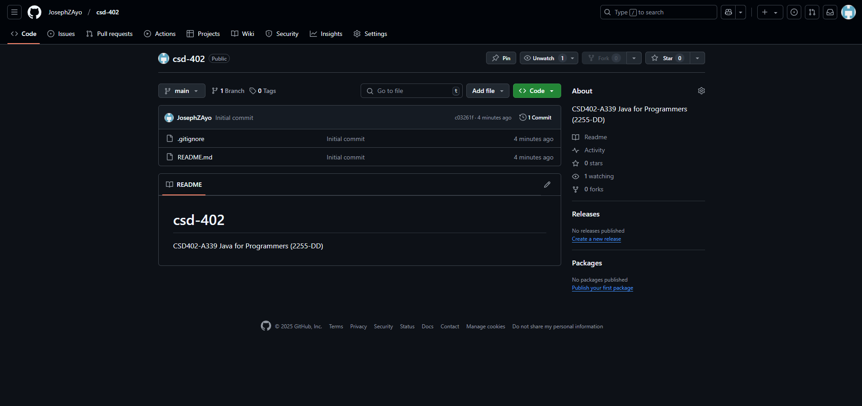

1. Screenshot of local directory (properly formatted)

